VISUALIZATION
Visualization is the process of showing data in a graphical or pictorial form so that people can easily understand patterns, trends, and insights.
Instead of reading long tables of numbers, visualization helps us understand data quickly using charts, graphs, and diagrams.
Visualization helps to:
- Understand complex data easily
- Identify trends and patterns
- Compare values quickly
- Make better decisions
- Present information clearly
Python has many libraries for data visualization, such as:
- Matplotlib – Basic plotting library
- Seaborn – Advanced statistical graphics
- Pandas – Simple built-in plotting from datasets
- Plotly – Interactive graphs
Visualization is used in many fields like:
- Business – Sales reports, profit charts
- Healthcare – Patient data trends
- Education – Student performance analysis
- Weather Forecasting – Temperature and rainfall charts
- Sports Analytics – Player and team performance tracking
Let us dive deeper into matplotlib and pandas.

MATPLOTLIB

Matplotlib is a highly versatile and widely-used Python library for creating a broad range of static, interactive, and animated visualizations. Its object-oriented architecture allows detailed customization of every plot element. Key features include extensive customization, seamless integration with NumPy arrays, and compatibility with Jupyter notebooks. It supports exporting plots to multiple file formats and embedding visualizations in GUIs or reports.​

Typical use cases:

Exploratory data analysis

Scientific publishing

Prototyping dashboards

Teaching visualization concepts

Key Features:
- Versatility: Supports a wide range of plot types such as line, bar, scatter, histogram, pie, boxplot, heatmap, and more, making it adaptable for diverse visualization needs.​
- Customization: Allows users to modify nearly every element—colors, grid styles, labels, legends, annotations, figure size, and more, ideal for detailed and publication-quality visualizations.​
- Integration: Seamlessly works with NumPy, Pandas, SciPy, and supports direct plotting from arrays or DataFrames in analytics workflows.​
- Multiple Backends: Compatible with GUI toolkits and Jupyter Notebooks, enabling both static and interactive charting.​
- Advanced Plots & Subplots: Includes built-in support for multi-panel (subplot) layouts, complex statistical charts, and layered figures for analytic dashboards.​
- Interactive & Animated Charts: Offers the ability to create zoomable, pannable, and animated visualizations for deeper data exploration.

PANDAS
Pandas is a leading Python library for fast, flexible manipulation and analysis of tabular data. It offers built-in visualization capabilities, allowing users to quickly generate common plots directly from DataFrames and Series. Key features include simple chaining of data analysis and plotting functions, efficient handling of large datasets, and seamless integration with Matplotlib for enhanced customization.​
Typical use cases:
- Exploratory data analysis
- Automated reporting in data pipelines
- Interactive analytics in notebooks

Key Features:
- Quick Plotting from DataFrames: Generates basic visualizations (line, bar, area, pie, scatter, boxplot) directly from Series or DataFrames with a single command, simplifying EDA and data exploration.​
- Automatic Labeling: Infers axis labels and legends from DataFrame structure, speeding up summary chart creation.​
- Integrated Analytics Workflow: Plots can be generated directly after data manipulation—combining cleaning, grouping, and visualization in a seamless workflow.​
- Grouping & Aggregation Visualization: Effortlessly visualizes grouped and aggregated data (e.g., via groupby or pivot tables), making it ideal for pivot analysis and category comparison.​
- Basic Customization via Matplotlib: Offers access to Matplotlib’s axes objects for further styling but with less granularity than direct Matplotlib usage.

Matplotlib Graph Types
Line Plot
- Description: Visualizes trends over intervals or time.
- Use case: Tracking changes in temperature over days.
Code snippet:
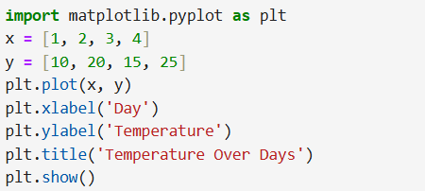
Output:
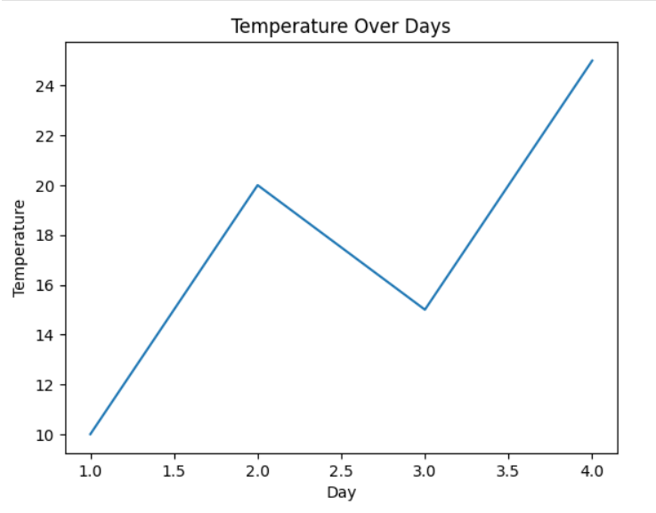
Scatter Plot
- Description: Displays relationships between two numerical variables.
- Use case: Correlation between study time and test scores.

Code snippet:
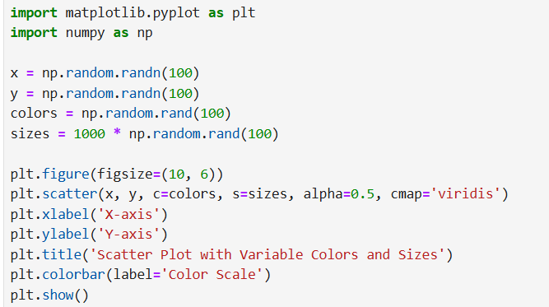

Output:
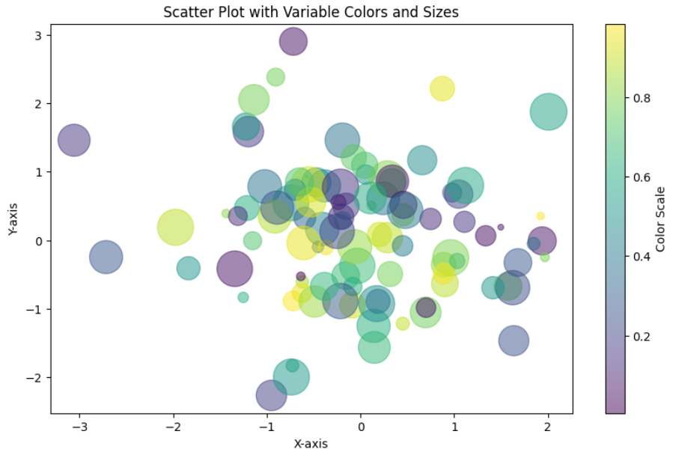

HISTOGRAM
- Description: Shows data distribution and frequency.
- Use case: Distribution of ages in a population.

Code snippet:
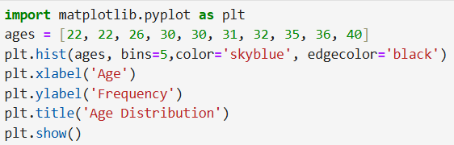
Output:
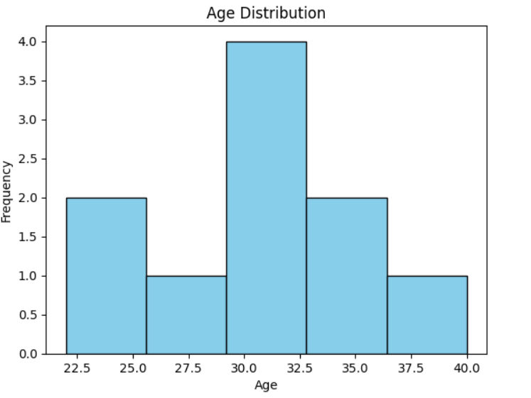

Bar Chart
- Description: Compares discrete categories.
- Use case: Sales across different products.
Code snippet:
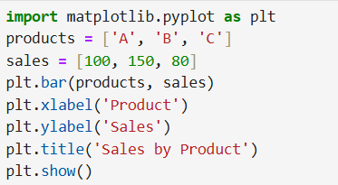
Output:
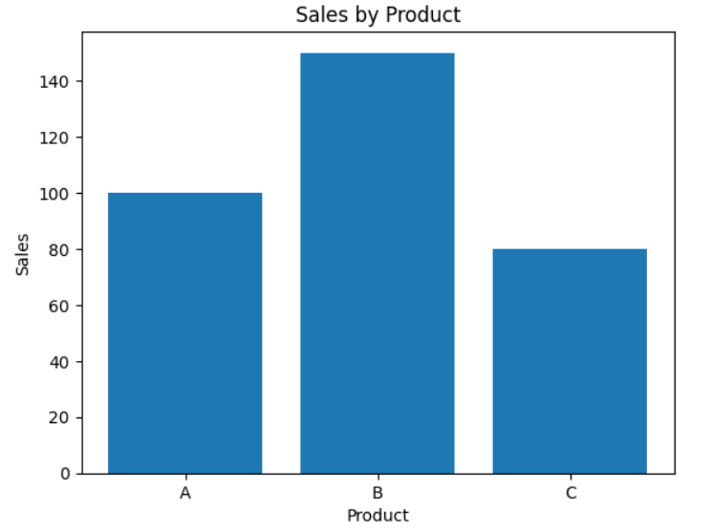

PIECHART
- Description: Pie charts visualize the proportion of categories within a whole. Matplotlib provides precise control over slice appearance, color, labels, and percentage annotations.​

- Use Case: Commonly used to display market share, poll results, or budget breakdowns.

Code snippet:
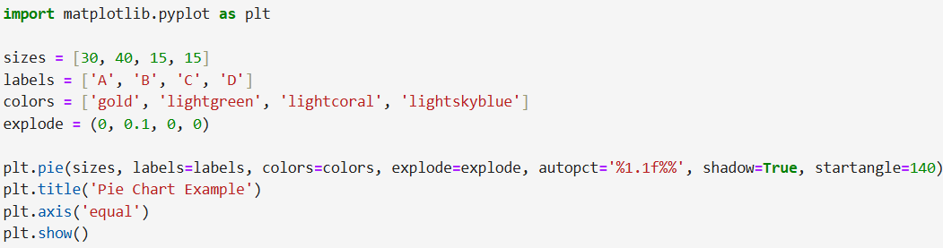

Output:
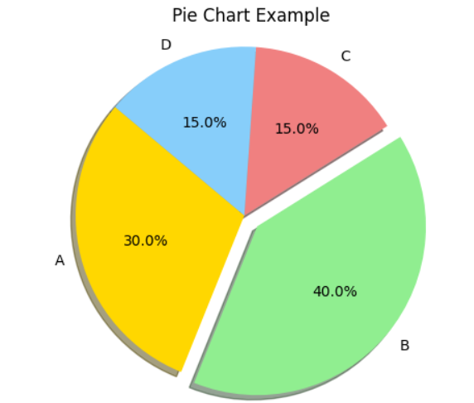
Unique features: Customizable slices, exploding segments, color mapping, shadow effects, and direct percentage labeling.

AREA CHART
- Description: Area charts visualize quantitative data trends over time or ordered categories by filling the area below a line. Matplotlib enables stacked or unstacked (single/multiple series) area plots, with extensive options for colors, transparency, and layering.​

- Use Case: Useful for showing cumulative values, such as sales growth, population change, or combined contributions from several categories.
Code snippet:
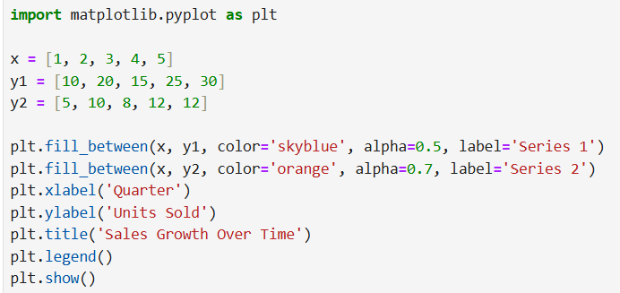
Output:
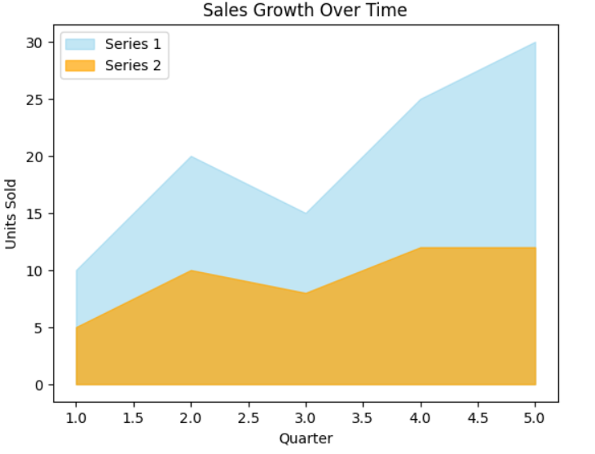
Unique features: Control over opacity, stacked/multiple series, legend support, color choices.

Heatmap with Seaborn
- Description: A heatmap visualizes matrix-style data by using color gradients to represent values, revealing patterns, correlations, and outliers in tabular data. While Matplotlib can display image-like heatmaps, Seaborn is commonly used for enhanced color mapping and annotation features on top of Matplotlib.​

- Use Case:
- Visualizing correlation matrices
- Displaying confusion matrices for classification results
- Representing spatial data, sensor grids, or game boards
Code snippet:
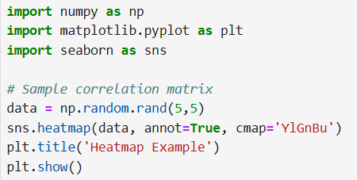
Output:
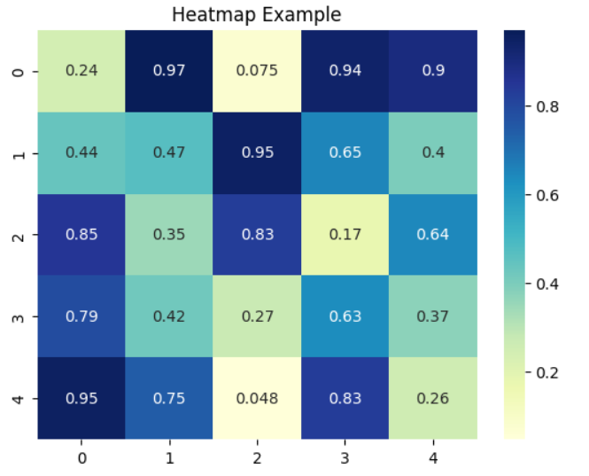

Regplot with Seaborn
- Description: A regplot visualizes the relationship between two variables and fits a linear or polynomial regression model, displaying both scatter points and trend lines. Seaborn’s regplot, built on Matplotlib, offers quick drawing of regression fits with options for confidence intervals and polynomial fits.​

- Use Case:
- Assessing relationships and trends in paired data such as advertising spend versus sales, or age versus income.
- Identifying fit quality and detecting outliers or non-linear trends.
Code snippet:
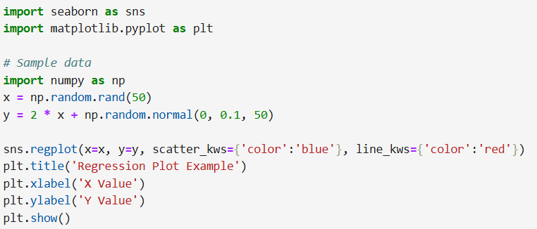
Output:
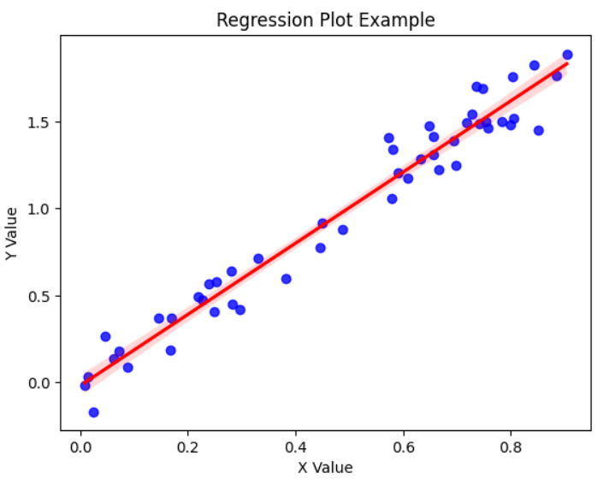

Pandas Graph Types
Bar Plot
- Description: Shows counts or values for categories.
- Use case: Display frequency of categorical values.

Code snippet:
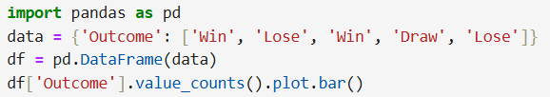

Output:
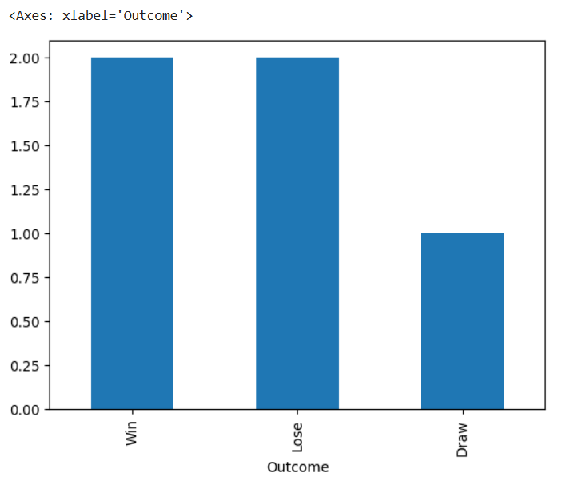

Box Plot
- Description: Summarizes distribution, highlighting quartiles and outliers.
- Use case: Compare spread of scores across student groups.

Code snippet:
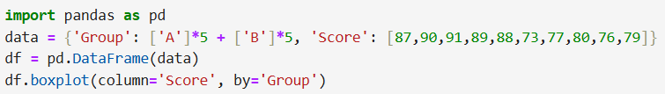

Output:
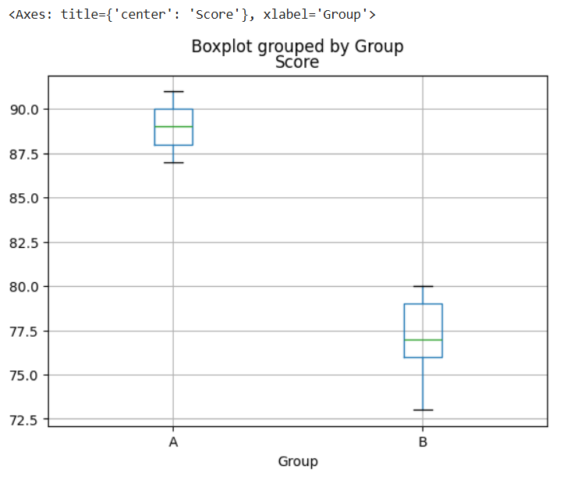

Histogram
- Description: Frequency distribution of numerical data.
- Use case: Age distribution within a DataFrame column.
Code snippet:
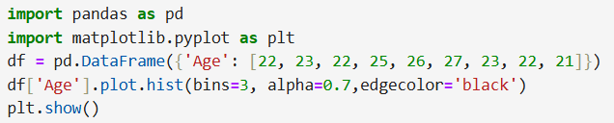
Output:
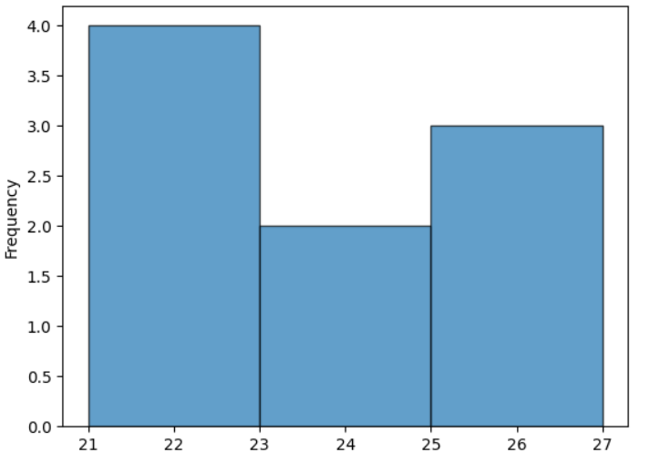
Pie Chart

Description: Pandas allows rapid creation of pie charts directly from Series or DataFrame columns using the built-in .plot.pie() method.​

Use Case: Ideal for fast visualization of categorical distributions in DataFrames, such as survey responses or product shares.

Code snippet:
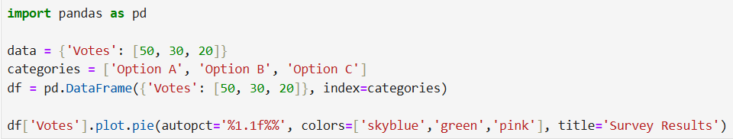

Output:
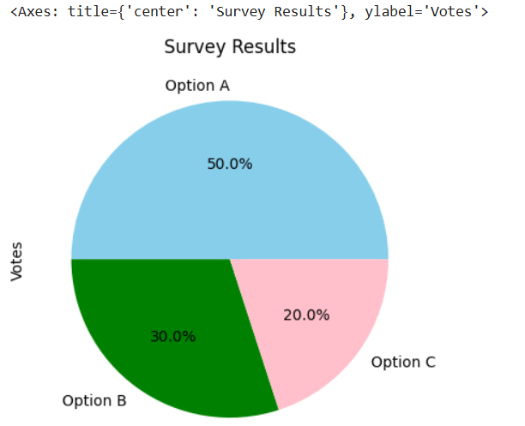
Unique features: Quick plotting from Series/DataFrame, labels auto-extracted from index, basic color customization.
Area Chart
- Description: Pandas enables quick creation of area charts from DataFrames using the .plot.area() method. It focuses on ease and speed, automatically stacking multiple series and using DataFrame indices for the x-axis.​

- Use Case: Ideal for visualizing how several quantities cumulatively change, such as resource usage, web traffic sources, or financial portfolio allocation.
Code snippet:
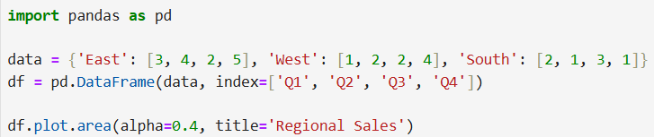

Output:
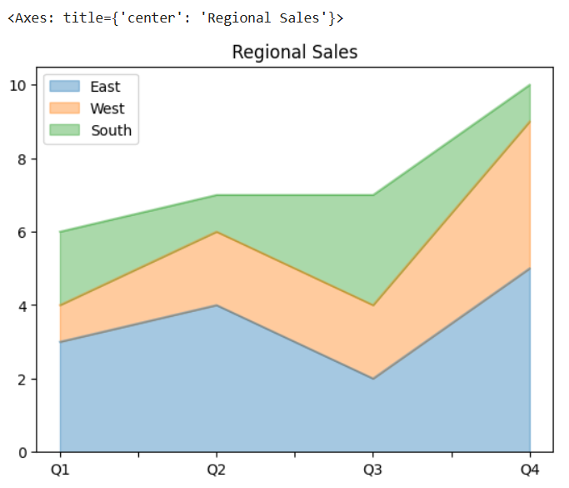
Unique features: Column stacking, fast plotting from tabular data, straightforward color mapping, integrated with Pandas analysis workflow.
Box Plot
- Description: Pandas simplifies box plot creation straight from DataFrames or Series, ideal for exploring spread and outliers among columns or groups.​

- Use Case: Quickly visualize the distribution of multiple columns or values grouped by categorical variables, such as scores across student classes or income levels.

Code snippet:
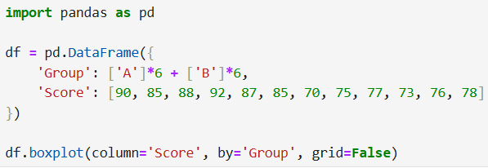
Output:
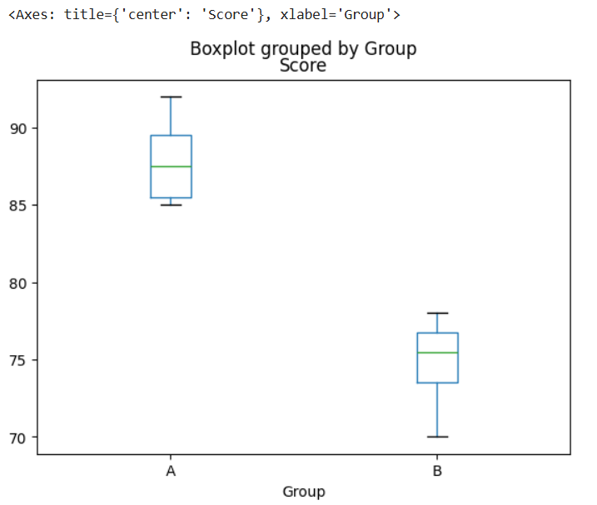

Heatmap
- Description: Pandas does not have a direct heatmap plot method but works seamlessly with Seaborn and Matplotlib. The typical workflow involves using a DataFrame (such as a correlation matrix or pivot table) as input for a Seaborn heatmap.

- Use Case: Quick visualization of DataFrame correlation tables. Identifying variable relationships in datasets.

Code snippet:
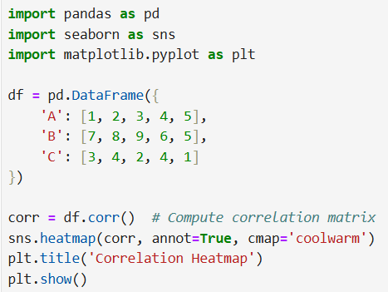
Output:
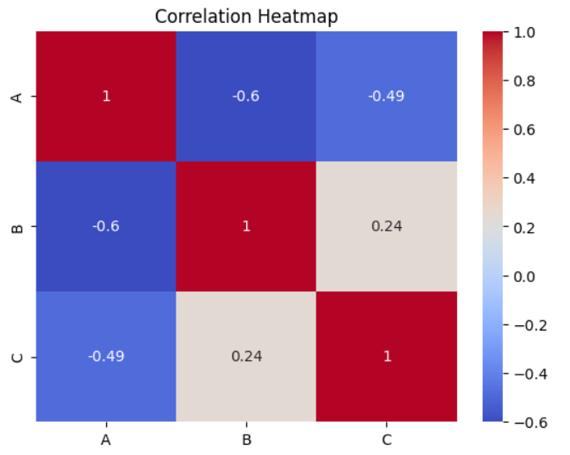
Unique features: Direct DataFrame input, quick correlation/relationship checks, easy value annotations and color customization.

Regplot
- Description: Pandas does not provide a direct regplot function, but its Series and DataFrame structure is commonly used to supply data for Seaborn’s regplot. Simple statistical summaries and plotting from DataFrames make it easy to prepare the necessary columns for regression analysis.​

- Use Case:
- Quickly passing columns from DataFrames to Seaborn for regression visualization
- Exploratory analysis for machine learning or modeling workflows
Code snippet:
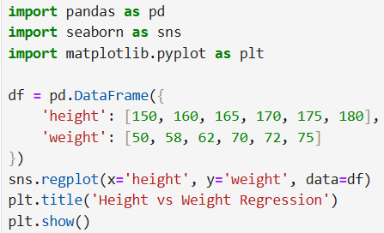

Output:
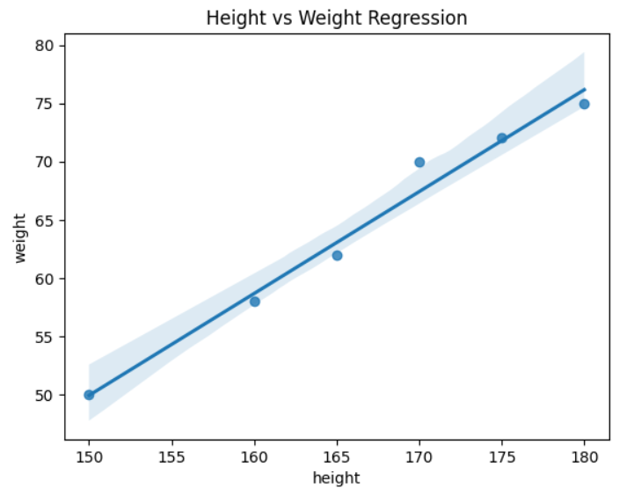

COMPARISON OF MATPLOTLIB AND PANDAS
- Foundation and Flexibility
  - Matplotlib is the core, most versatile visualization library in Python, offering full control over every plot attribute, from layout to individual style elements.​
  - Pandas plotting is a high-level, convenient wrapper built on Matplotlib, focused on summarizing DataFrame or Series data with minimal code.​
- Ease of Use
  - Pandas lets users create quick plots directly from data frames and series in one line, ideal for rapid data exploration and prototyping.​
  - Matplotlib requires more setup and explicit configuration but supports advanced chart types and customizations that Pandas alone cannot achieve.​
- Customization
  - Matplotlib is best for publication-quality and advanced graphical tweaks, supporting unique layouts, multi-axes figures, annotations, colors, fonts, and more.​
  - Pandas plotting offers limited customization – for deeper styling, users often access the underlying Matplotlib axes and methods.​
- Integration and Workflow
  - Pandas excels in analytics workflows by letting you chain data transformation and visualization, especially during Exploratory Data Analysis (EDA).​
  - Matplotlib is essential for preparing figures for reports, presentations, or interactive GUIs and integrates with many other visualization libraries like Seaborn and Plotly.​
- Supported Plot Types
  - Matplotlib supports nearly all standard 2D (and some 3D) plot types: line, scatter, histogram, bar, area, pie, boxplot, heatmap, and more.​
  - Pandas covers the core chart types: line, bar, area, pie, boxplot, and scatter, which are most useful for structured tabular data.​
- Performance
  - Both libraries handle large datasets well, but Pandas is faster for basic charts from structured data, while Matplotlib offers more flexibility for customizing performance-related parameters.​

Advantages of Matplotlib:
- Extensive customization of chart elements and formats for any dataset.​
- Broad variety of supported plot types and advanced visualizations.​
- Ideal for creating presentation- and publication-ready graphics.
- Integrates natively with Pandas, NumPy, Seaborn, and more for powerful multi-library workflows.​
- Essential when advanced data annotations, multi-figure layouts, or animation is required.

Advantages of Pandas:
- Effortless, quick plotting directly from DataFrames and Series.​
- Intuitive for data analysis—no need for extensive formatting or setup.​
- Perfect for rapid prototyping and exploratory analysis.
- Automatically infers axis labels and legends for summary charts.
- Seamless integration within the Pandas data manipulation workflow.

In conclusion, use Pandas for fast, simple data visualizations during analysis, and switch to Matplotlib when absolute control, versatility, or presentation polish is needed.

When to Use Each Library
When to Use Matplotlib
- Use Matplotlib when complete control over the appearance, layout, and formatting of your charts is required. It is ideal for situations where publication-quality visualizations are needed, such as research papers, formal reports, or presentations.​
- Choose Matplotlib for advanced chart types, custom annotations, multi-figure layouts, or when you need to embed visualizations into GUI applications or dashboards.​
- It’s best suited when your visualizations demand more than basic formatting, including custom colors, axes, legends, or when combining multiple types of plots in a single figure.​
When to Use Pandas
- Use Pandas for quick, exploratory visualizations directly from DataFrames and Series—especially during early analysis, data cleaning, or when quickly summarizing data.​
- Choose Pandas when you need to visualize grouped, aggregated, or pivoted data, and speed is important. It’s perfect for rapid prototyping, generating summary charts, or sharing results in a notebook during Exploratory Data Analysis (EDA).​
- Pandas is most efficient when the goal is to plot basic charts with minimal code, leveraging its integrated workflow with data manipulation and summary statistics.​

Performance Considerations
Matplotlib Performance
- Matplotlib is built for flexibility and customizability, which can add overhead for simple plots but allows optimizations for complex graphics and large datasets.​
- It efficiently handles large arrays, especially when using NumPy, but rendering complex figures with many plot elements (markers, lines, text, etc.) may slow down responsiveness, especially in interactive environments.​
- For very large datasets, it’s recommended to reduce the amount of plotted data (downsampling), use efficient backends, and avoid excessive overlays or annotations.​
- Saving high-resolution images or exporting interactive figures can consume significant memory and processing, so performance tuning (such as using agg backend for non-GUI plotting) is important for large workflows.​

Pandas Performance
- Pandas plotting is optimized for speed with tabular, structured data, making it perfect for small-to-medium-sized DataFrames with typical visualization needs.​
- When dealing with larger datasets or complex charts, Pandas plotting will pass the data to Matplotlib, so performance will depend on Matplotlib's capabilities.​
- Basic plots like line, bar, and histogram are handled rapidly, and aggregation/grouping is performed in-memory before plotting, which is efficient until data volume exceeds memory limits or visualization complexity grows.​
- For massive datasets or high-frequency updates, consider subsampling data for visualization or using lightweight alternatives designed for big data (like datashader or plotly).​

